1. Which is the correct DataWeave expression to transform the input to the output shown below? 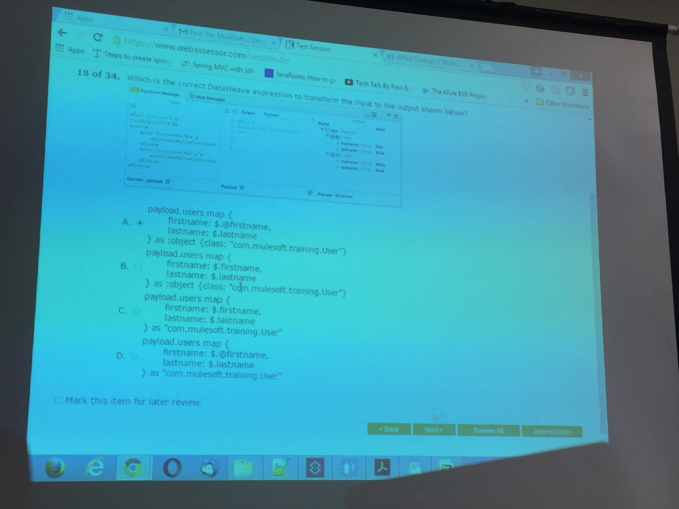
2. In the flow below, which option best describes the JMS endpoint? 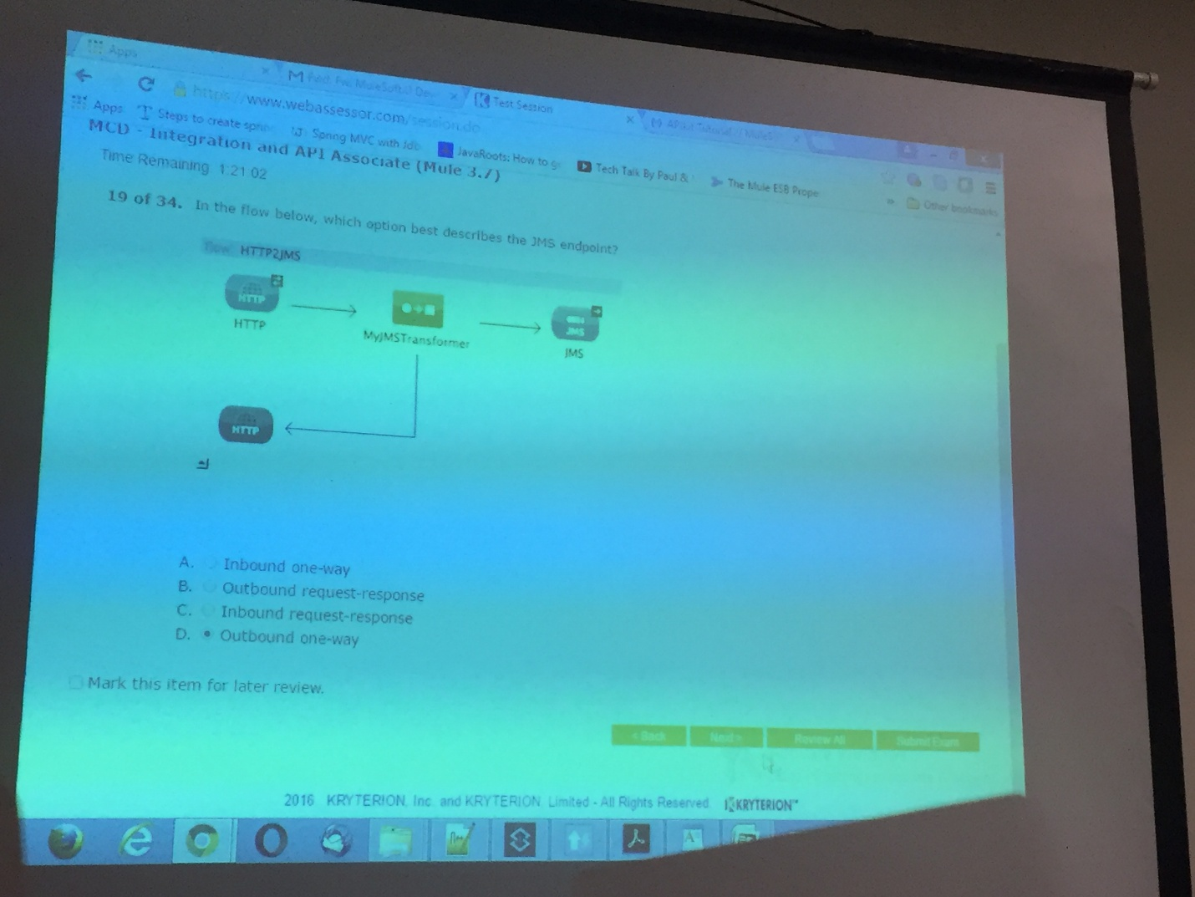
3. Which “three” statements about DataWeave transformation are true? 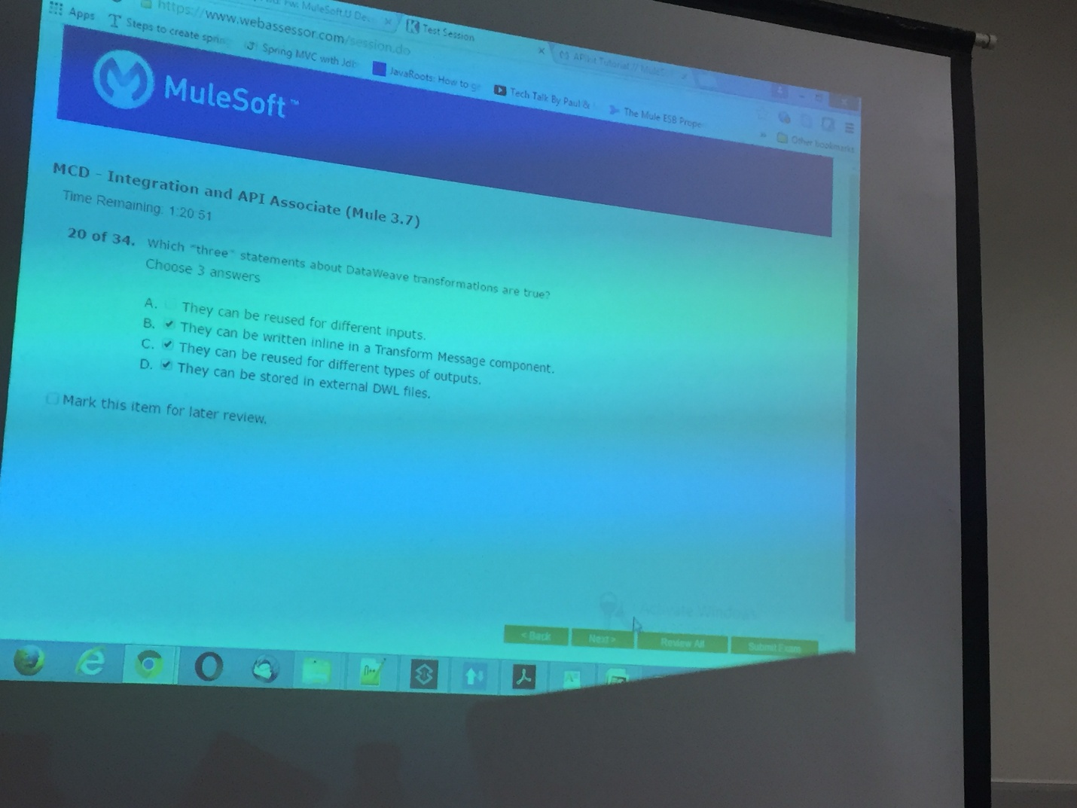
4. Which of the following configurations is valid? 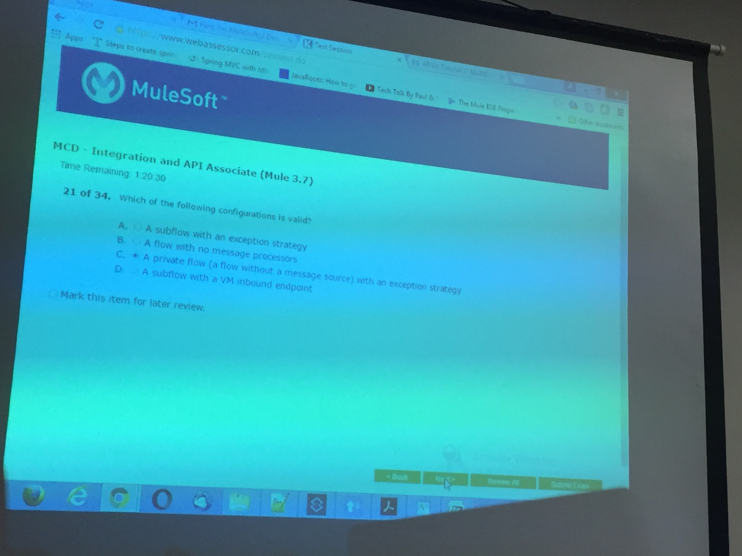
5. Mule applications deployed to various environments (QA, Staging, Production) do not contain the same connection attribute values. How can you best ensure the connection attribute values change based on the environment context? 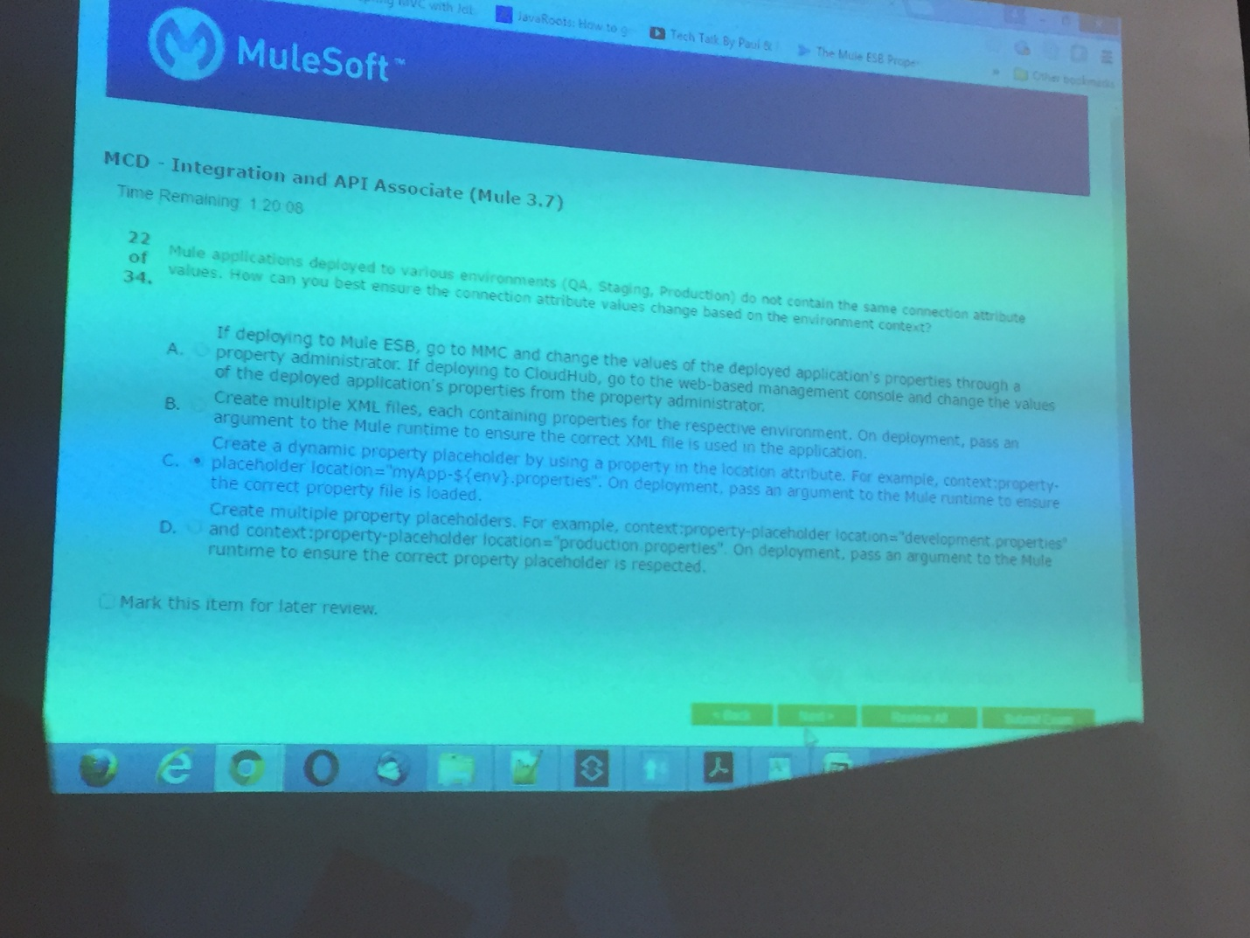
6. When separating a mule application into multiple mule configuration (XML) files, which of the following is true? 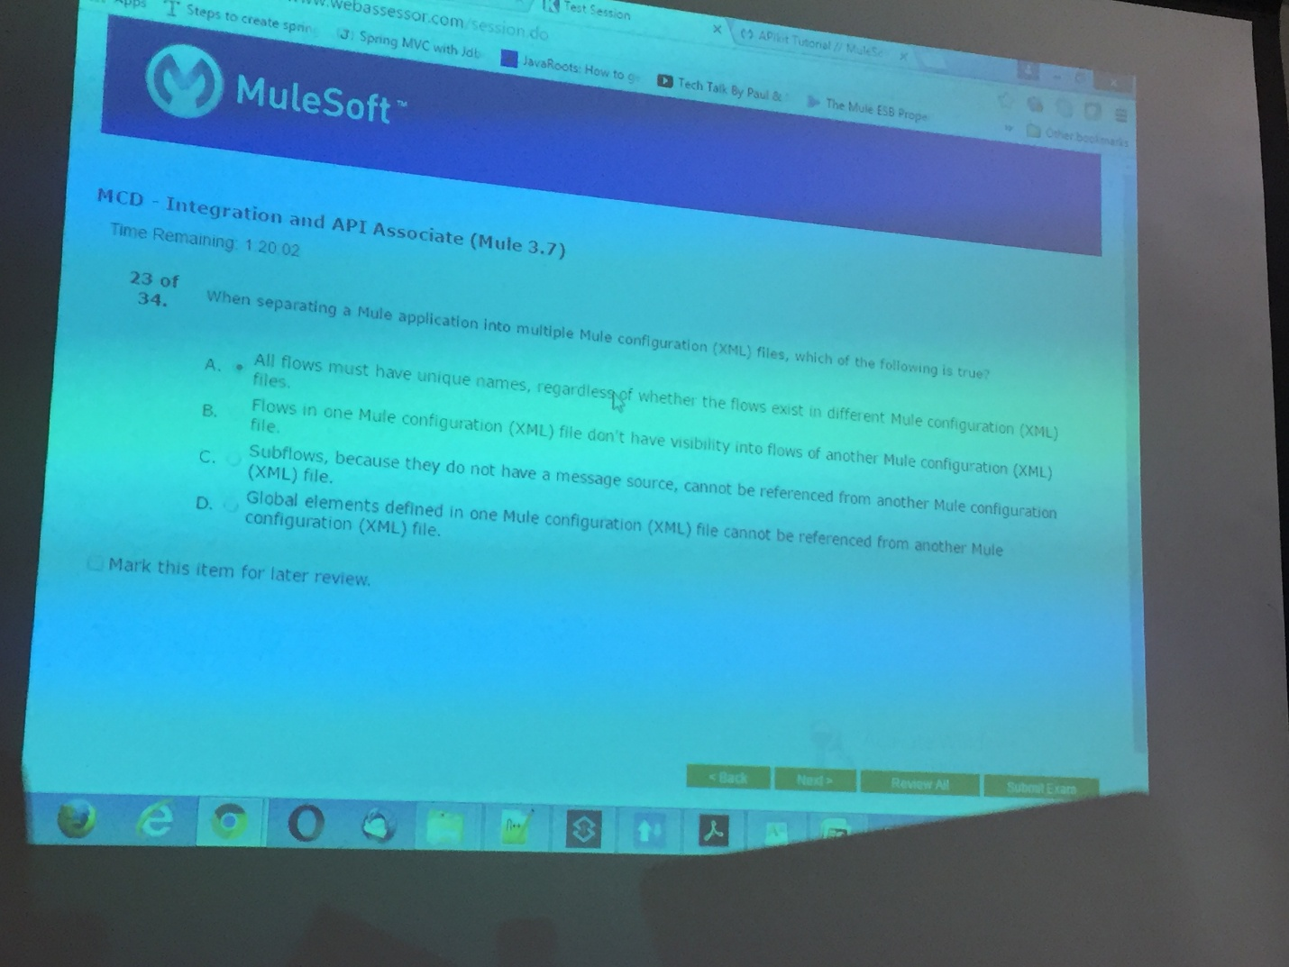

A flow

1. A flow needs to be exposed at http://{host}/myPath for users to retrieve data. Assuming the flow already exists, what are the minimum elements needed to achieve this? 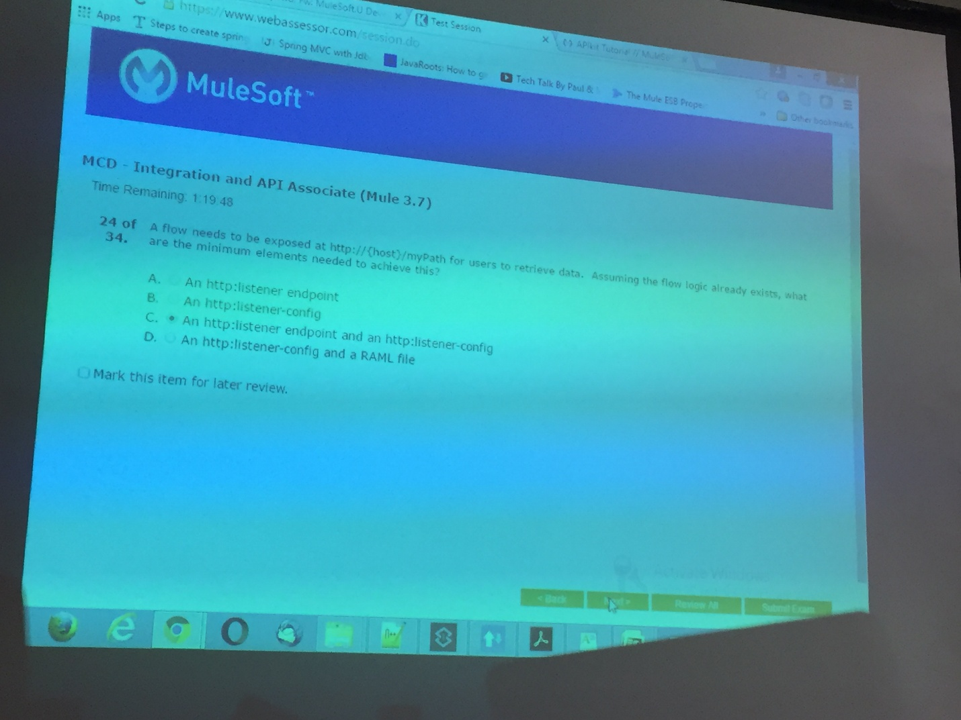
2. When the firstFlow below calls the secondFlow, where will mule message be sent? 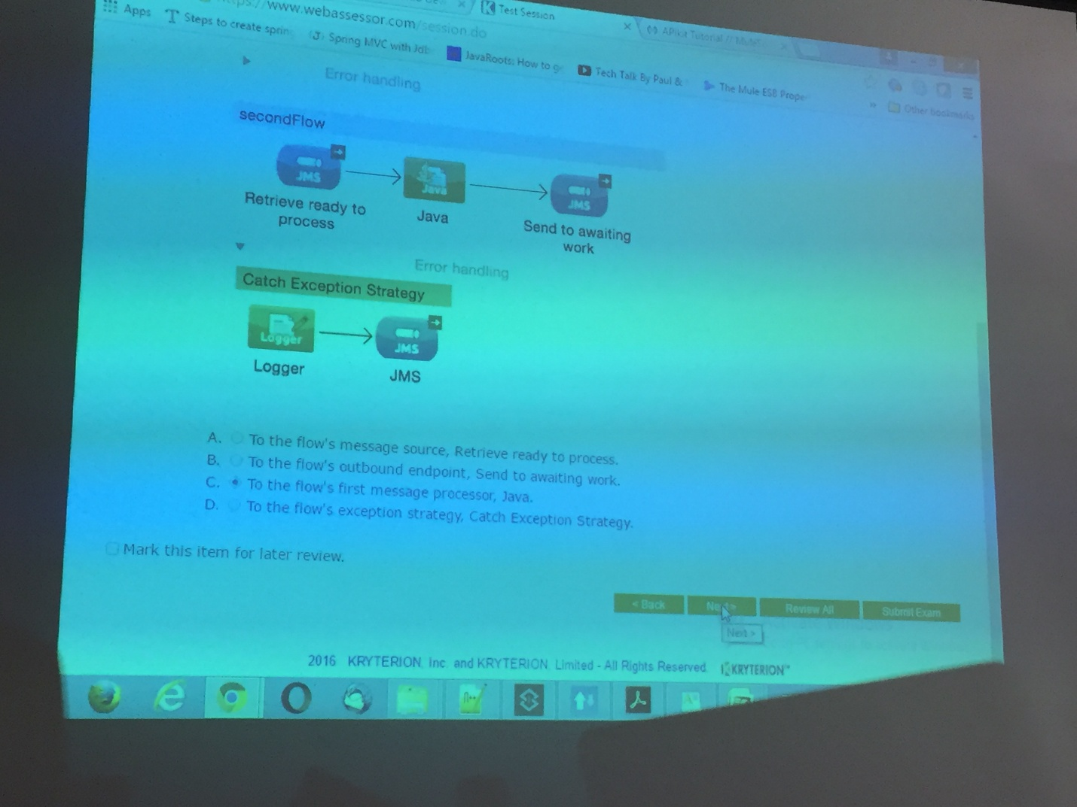
3. An exception is thrown when the following flow is executed. What is the most likely cause? 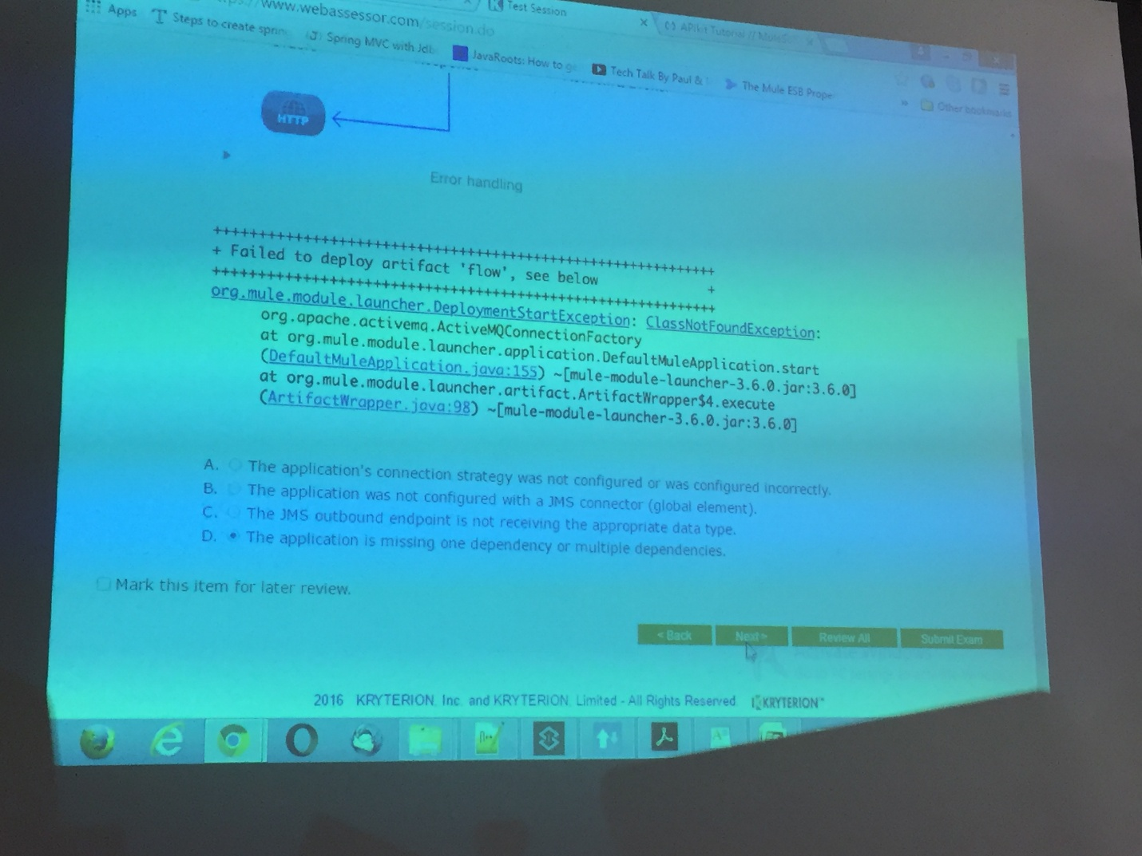
4. In the flow below, what is the correct configuration of the message processor at point A to extract the 3rd result’s FullName field from the database result before writing the payload to a file? 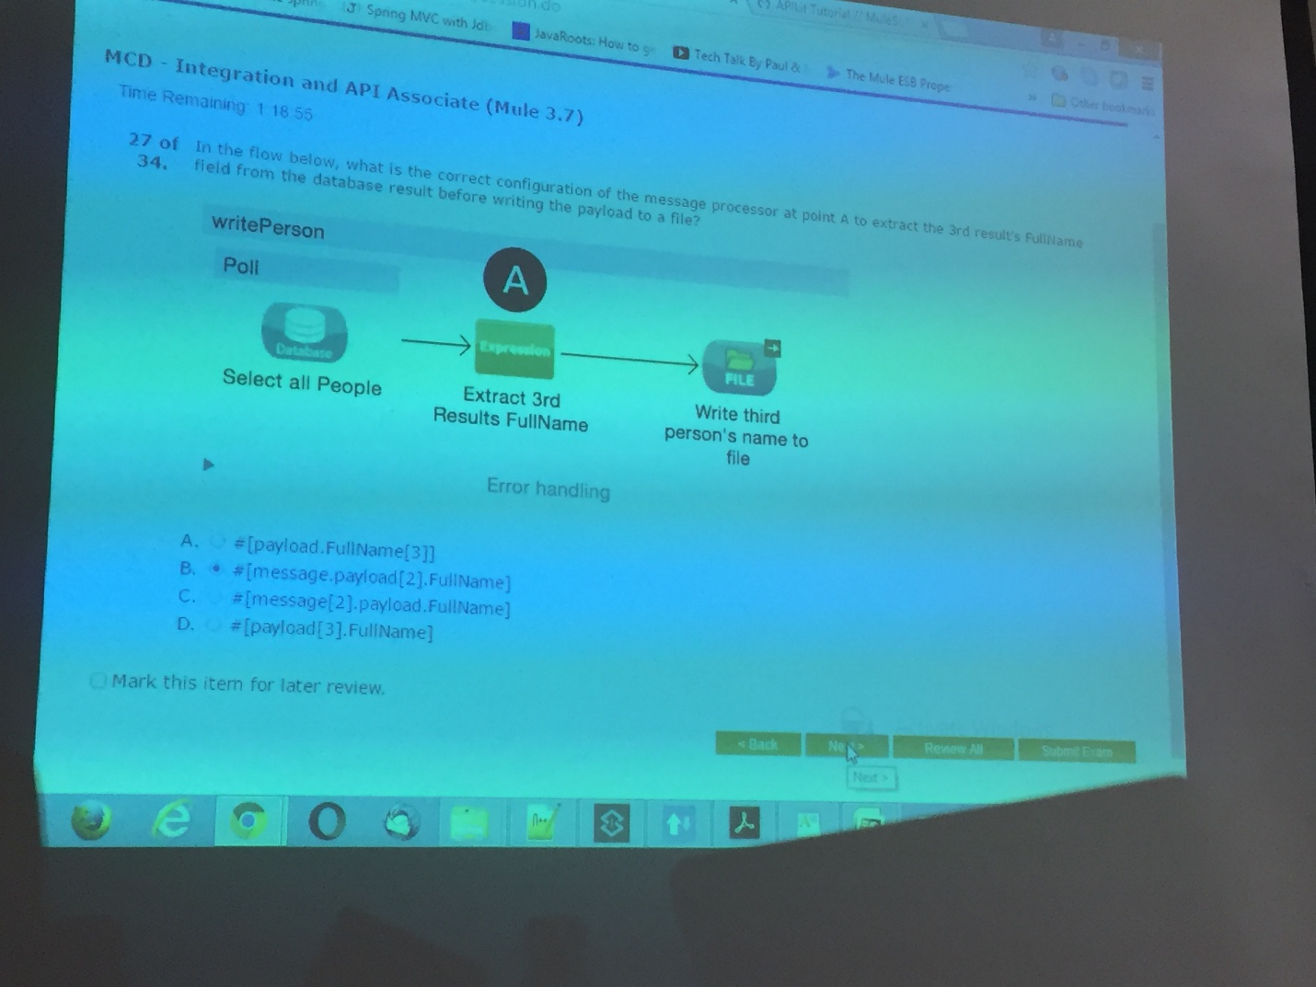
5. Errors need to be handled the same way for multiple flows (but not all flows) in a mule application. Which of the following approaches can be used to prevent redundancy in the applications? 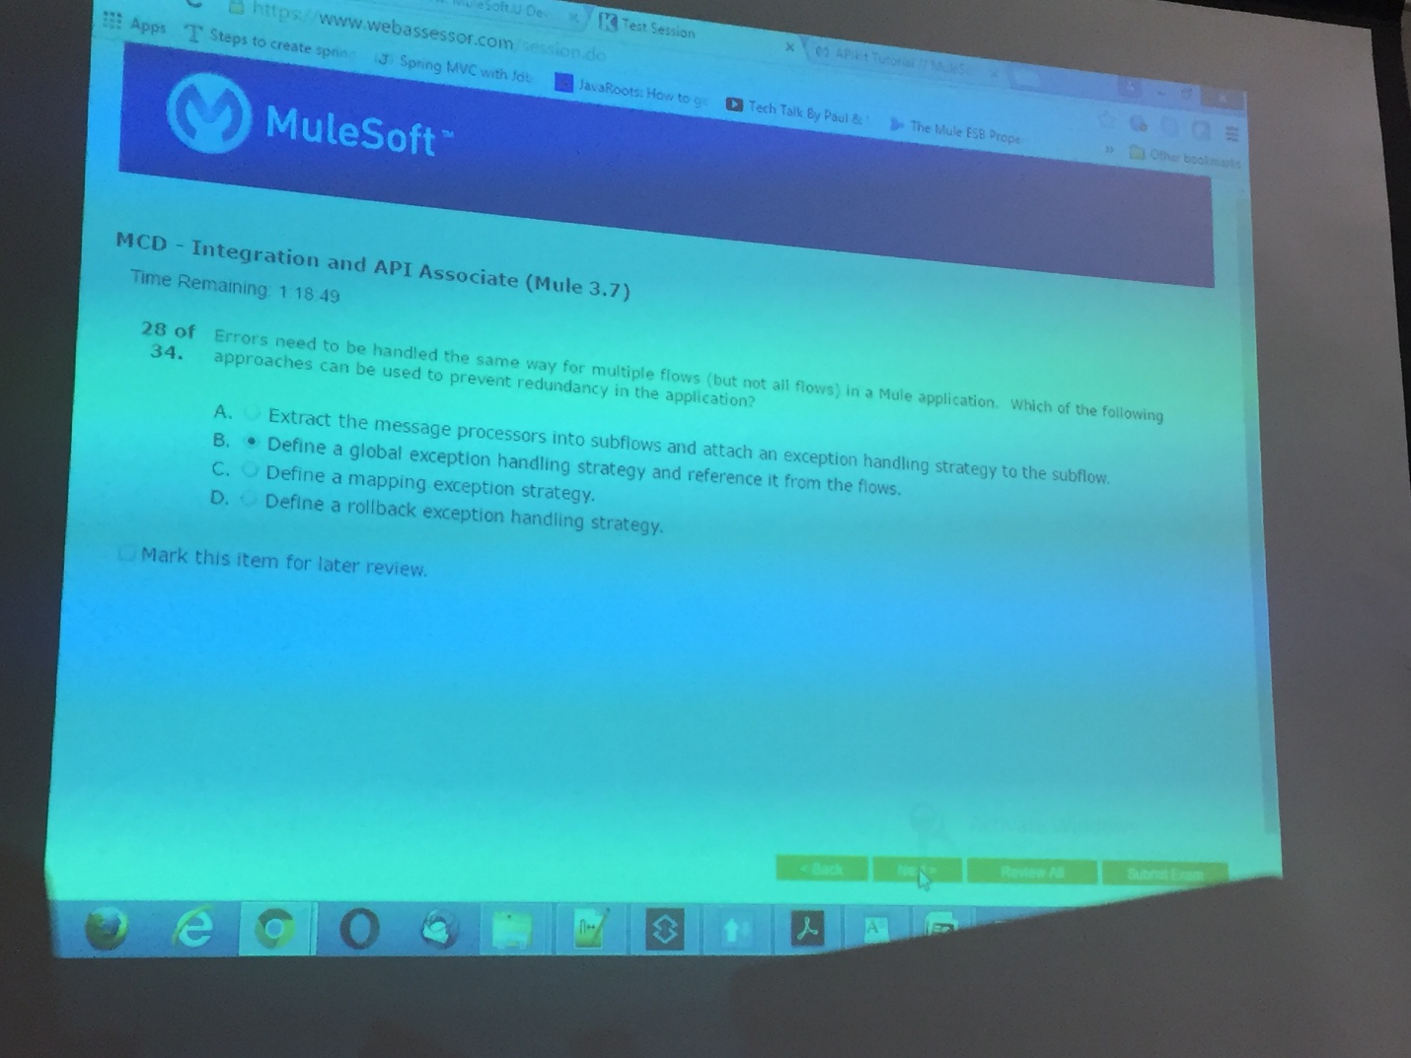
6. In a DataWeave transformation, which of the following is th e correct syntax to reference a flow variable called username? 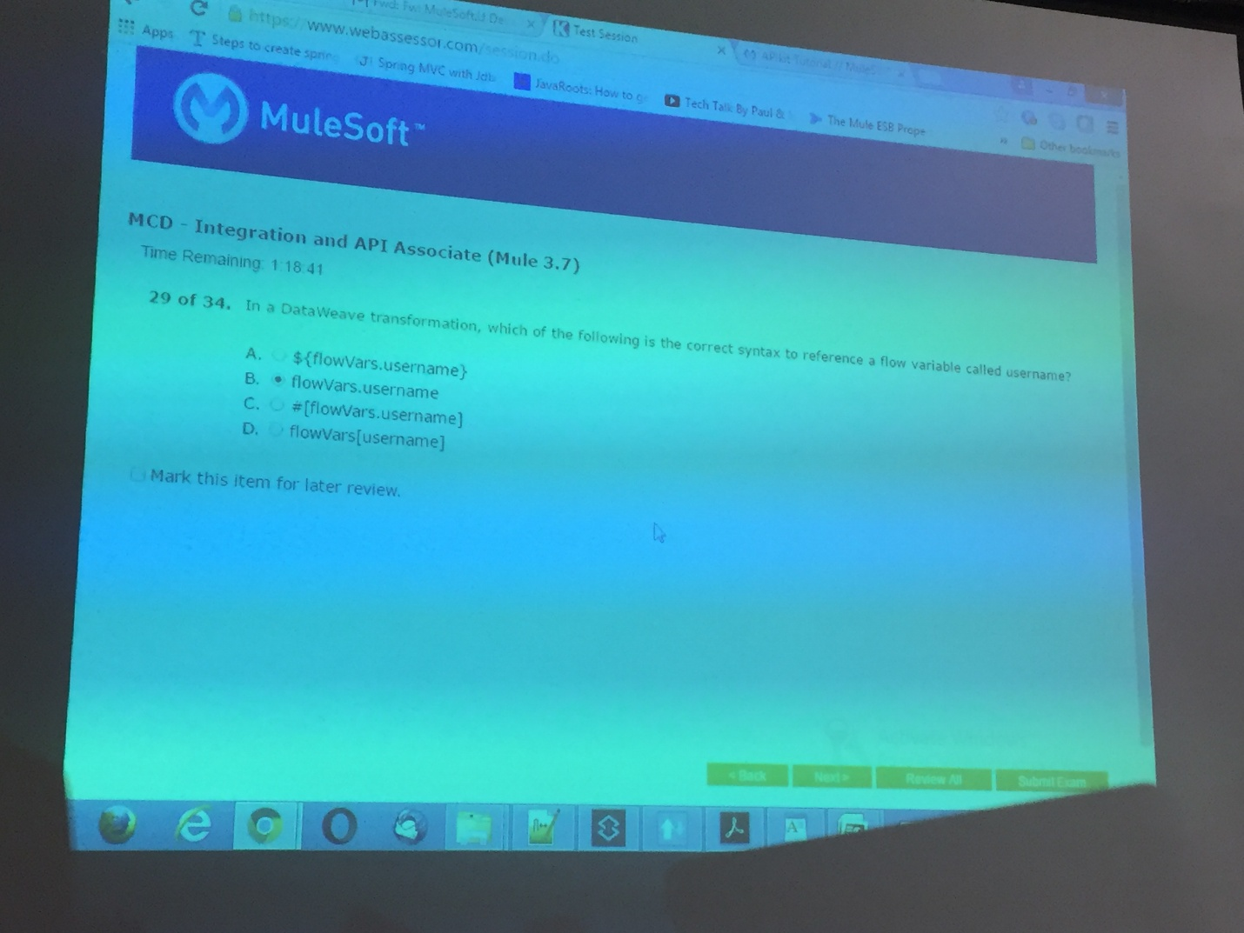
7. In the flow below, what data type is expected at point Y? 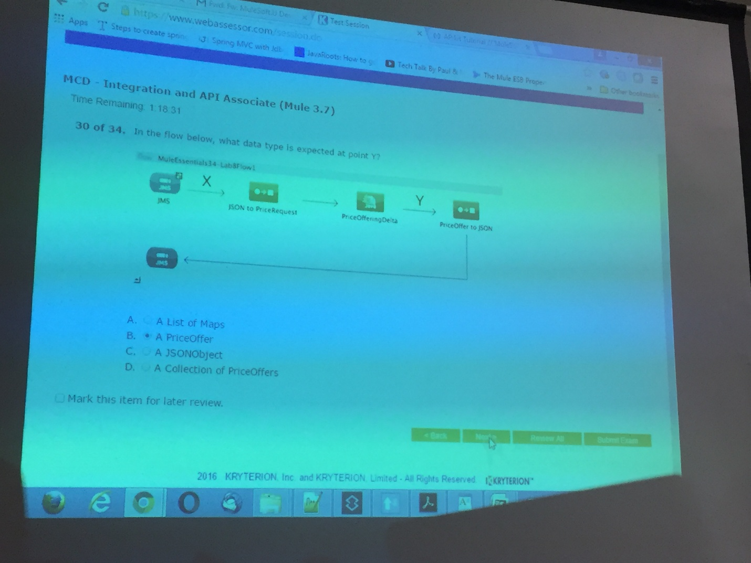
8. One route in a scatter-gather router throws an exception and the exception is not handled by the flow or resource being called. Without additional configuration, how will scatter-gather handle this situation? 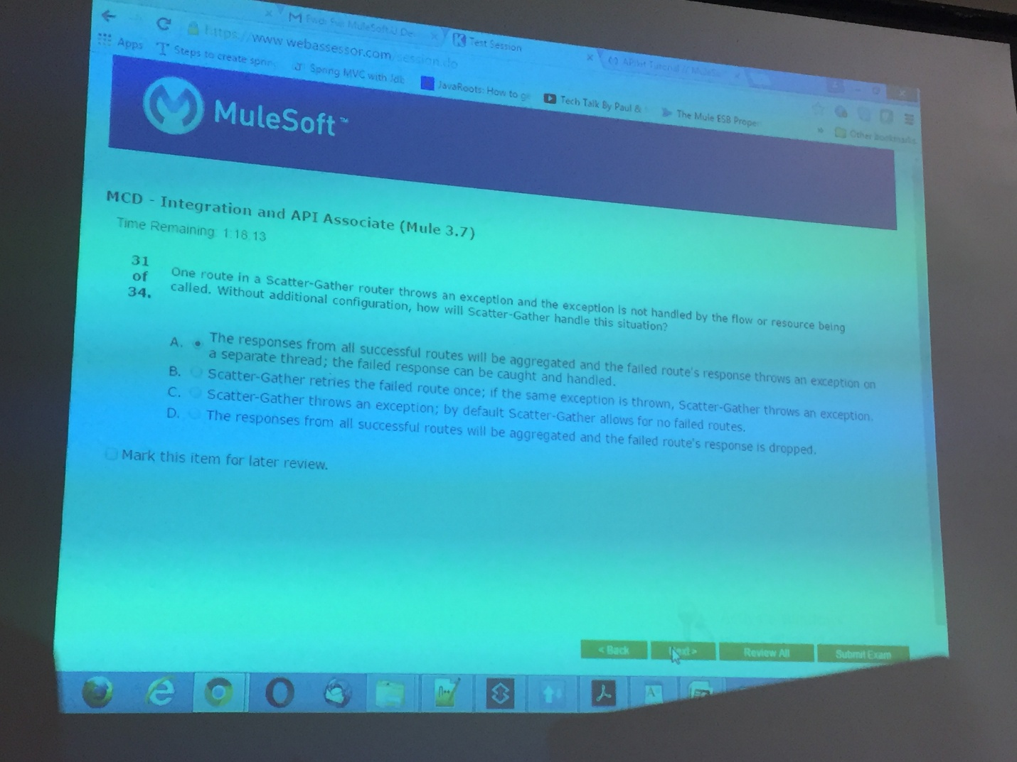
9. A flow has the following configuration: 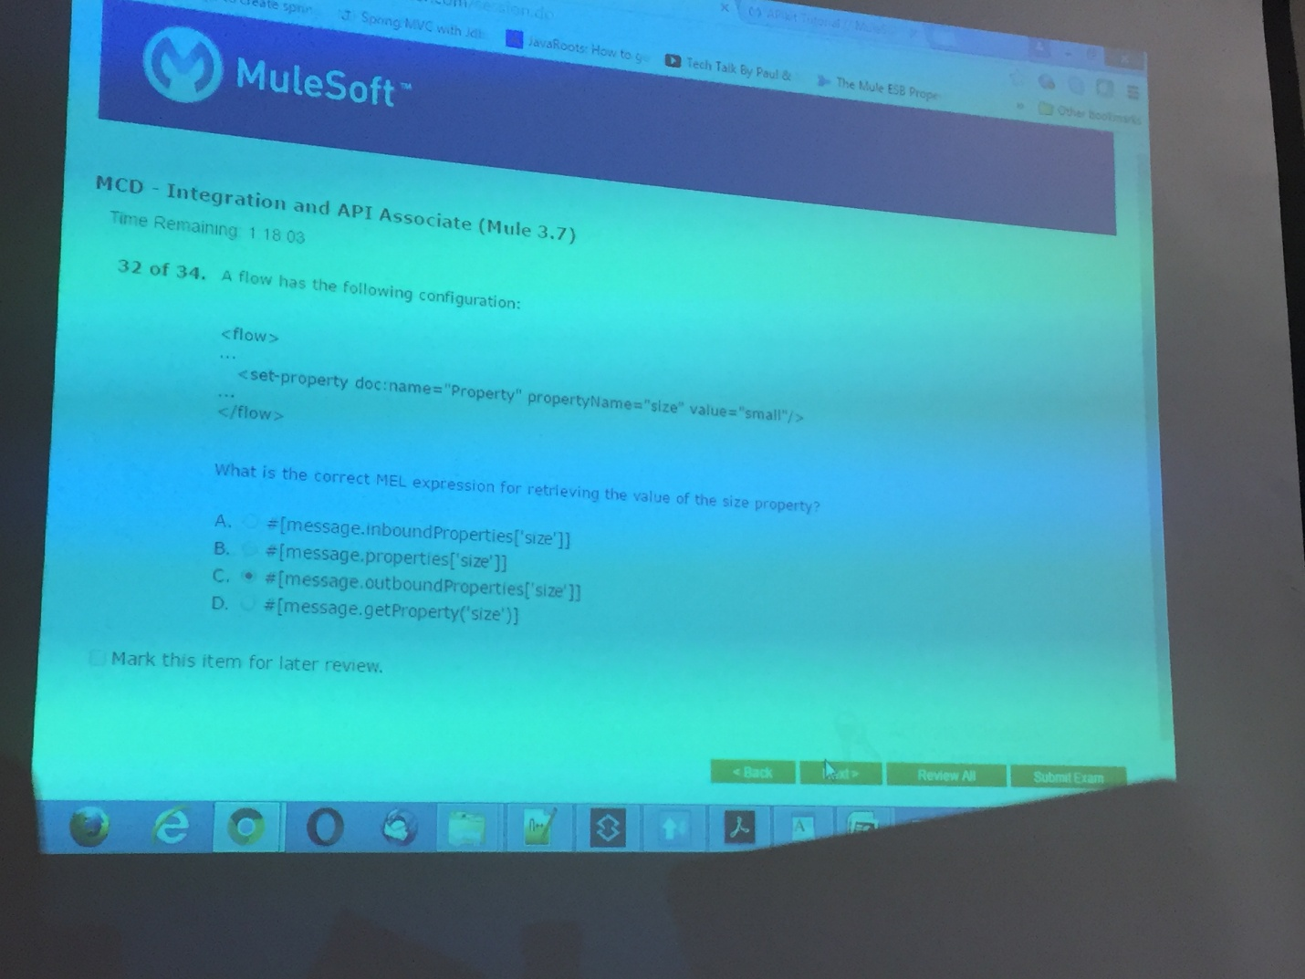
10. What is the default behavior of a filter? 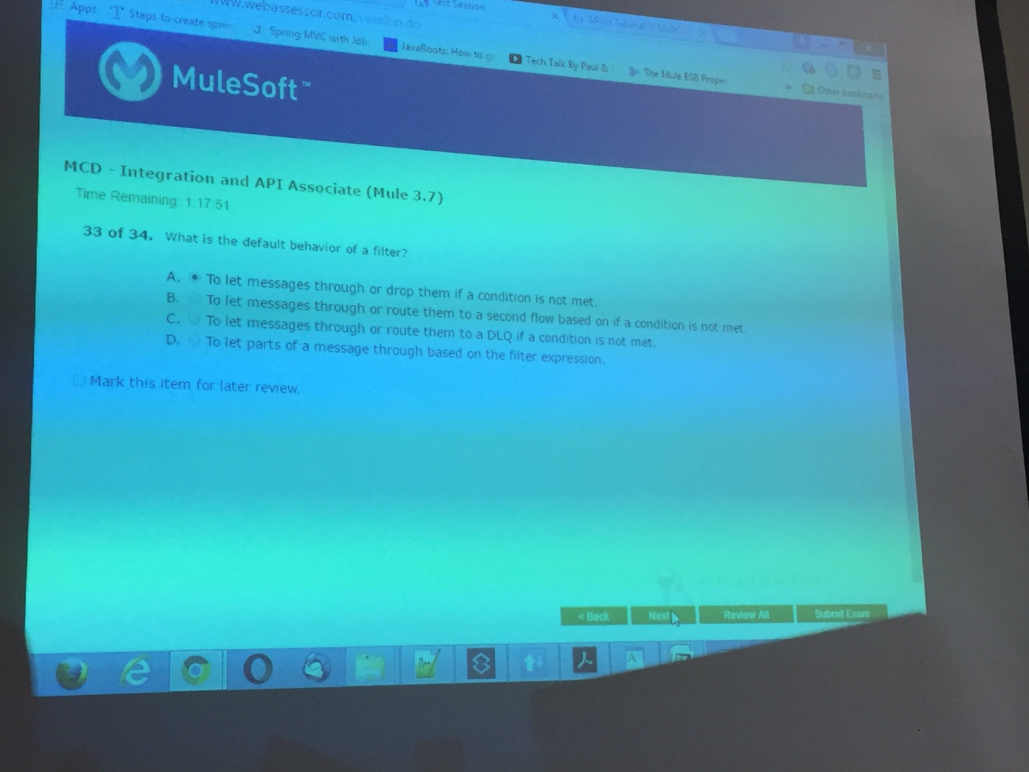
11. In the application below, what execution behavior can be expected when an exception is thrown at point A? 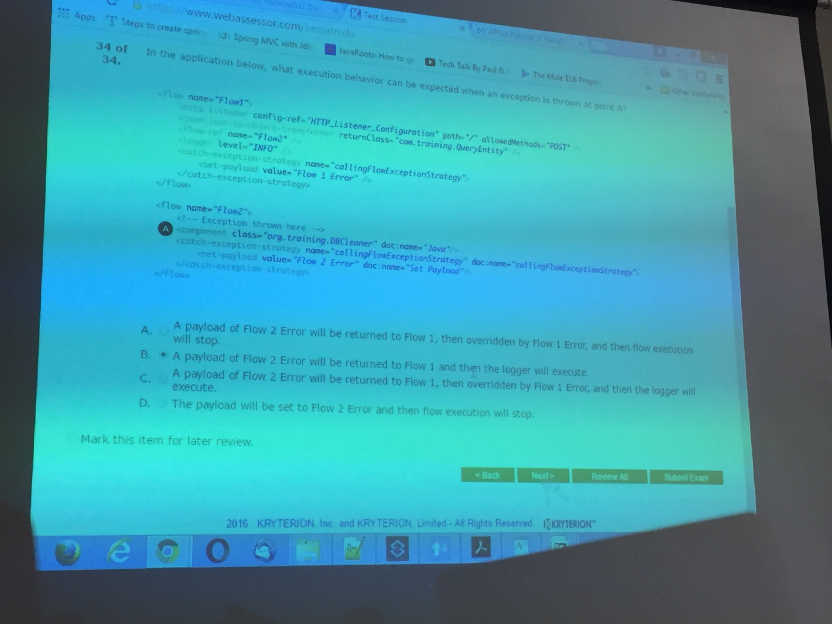
12. Question unknown